*Heaven’s light is our guide.*

*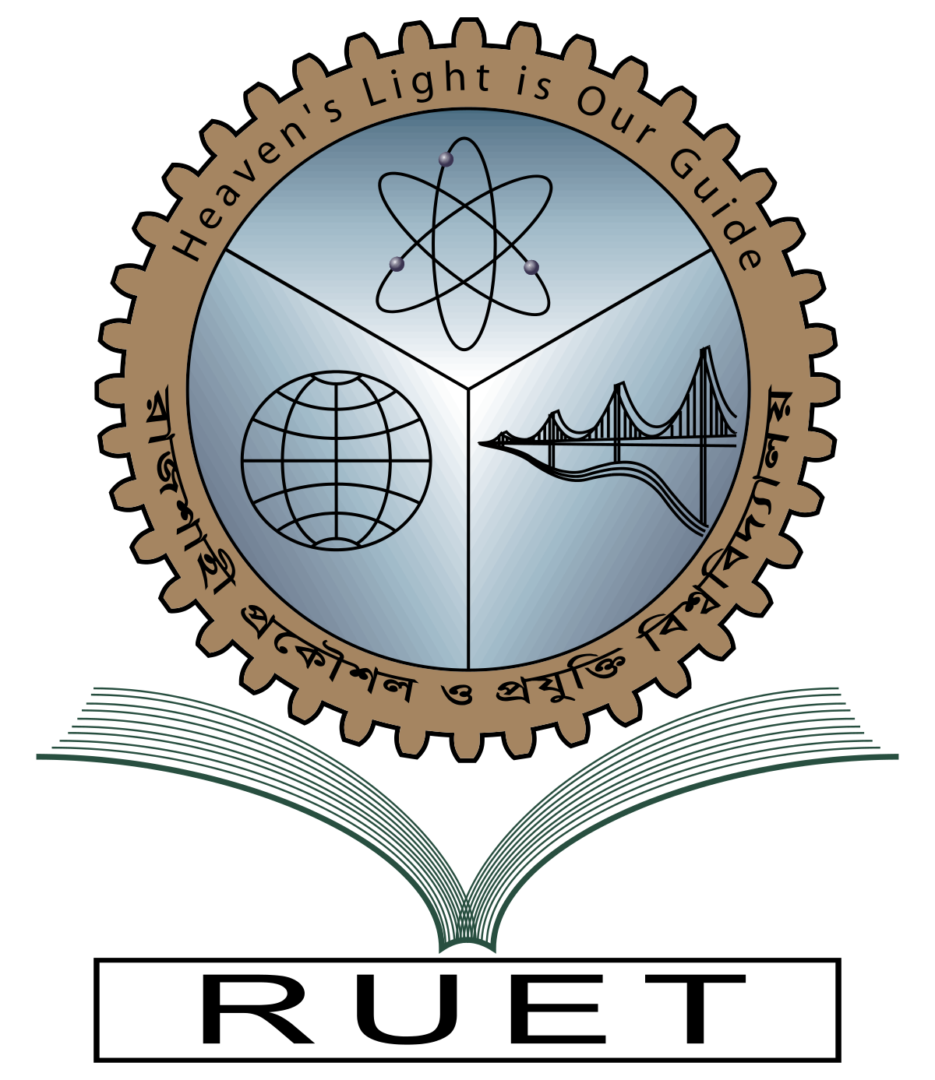***Rajshahi University of Engineering and Technology**

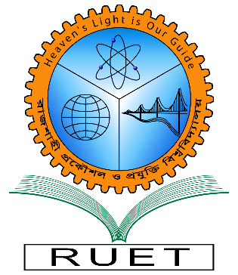

**Department of Electrical & Electronic Engineering**

**Course no.** EEE 3204

**Course title:** Power Electronics Sessional

**Experiment no.** 05

**Experiment name:** Experimental analysis of 555 timer base boost converter

**Date of experiment:** December 17, 2022

**Date of submission:** January 7, 2023

|  |  |
| --- | --- |
| **Submitted by:** | **Submitted to:** |
| **Ashraf Al- Khalique**  **Roll:** 1801171  **Session:** 2018-2019  Dept. of Electrical & Electronic Engineering,  Rajshahi University of Engineering and Technology. | **Md. Abdul Malek**  **Assistant Professor**  Dept. of Electrical & Electronic Engineering,  Rajshahi University of Engineering and Technology. |